

**PROJECT FOR SQL MODULE**

**ART GALLERY COMPETITION MANAGEMENT**

**Institute name** = Itvedant education Pvt. Ltd.

**Name** = Ayush Dnyaneshwar Gunjal

**Email address** = [ayushgunjal2002@gmail.com](mailto:ayushgunjal2002@gmail.com)

**Date of submission** = 27-07-2024

**Project aims:**

* **Artist Commission Management:** Calculate and track artist commissions on artwork sales.
* **Exhibition Scheduling:** Schedule and manage exhibitions, including booking dates and artwork selection.
* **Artwork Conservation Management:** Track and manage artwork conservation and restoration activities.
* **Marketing and Promotion:** Support marketing and promotional activities, including email campaigns and social media integration.
* **Financial Management:** Integrate with financial systems to manage artwork sales, commissions, and expenses.
* **Artist Management:** Store and manage information about artists, including their personal details, artworks, and exhibitions.
* **Artwork Management:** Store and manage information about artworks, including their title, medium, size, price, and artist.
* **Exhibition Management:** Store and manage information about exhibitions, including their title, start and end dates, and participating artworks.
* **Customer Management:** Store and manage information about customers, including their personal details and artwork purchases.

**Project objective:**

The objective of the Art Gallery Management Database project is to design and implement a comprehensive database system that efficiently manages and stores information related to the art gallery's operations, including artist and artwork details, exhibitions, customer interactions, sales, and conservation activities. The system aims to streamline gallery operations, improve data accuracy and accessibility, enhance customer engagement, and support business growth through data-driven insights and reporting. By achieving this objective, the project will provide a robust and scalable solution for the art gallery to manage its diverse activities, make informed decisions, and maintain its competitive edge in the art industry.

**ER diagram of the project:**

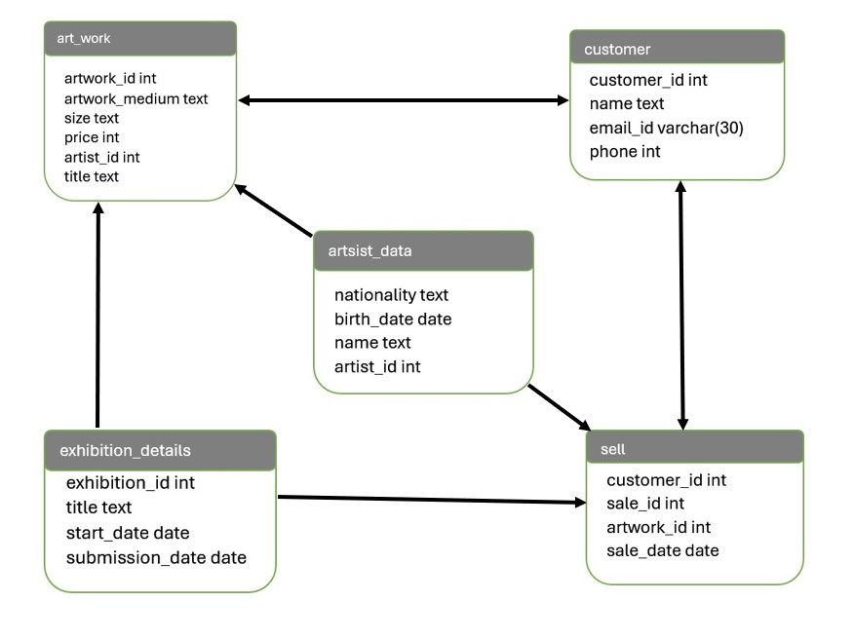

**ER diagram description:**

**Entities:**

* Artist (Artist_ID, Name, Birthdate, Nationality)
* Artwork (Artwork_ID, Title, Medium, Size, Price, Artist_ID)
* Exhibition (Exhibition_ID, Title, Start_Date, End_Date)
* Customer (Customer_ID, Name, Email, Phone)
* Sale (Sale_ID, Artwork_ID, Customer_ID, Sale_Date, Price)

**Relationships:**

* An artist can create many artworks (one-to-many).
* An artwork is created by one artist (many-to-one).
* An exhibition can feature many artworks (one-to-many).
* An artwork can be part of many exhibitions (many-to-many).
* A customer can purchase many artworks (one-to-many).
* A sale is associated with one artwork and one customer (many-to-one).

**Table description:**

1. **art_work**

|  |  |  |  |  |  |
| --- | --- | --- | --- | --- | --- |
| **Field** | **Type** | **Null** | **Key** | **Default** | **Extra** |
| artwork_id | Int | Yes | Primary key | Null |  |
| artwork_medium | Text | Yes |  | Null |  |
| size | Text | Yes |  | Null |  |
| price | Int | Yes |  | Null |  |
| artist_id | Int | Yes | Primary key | Null |  |
| Title | Varchar(100) | yes |  | Null |  |

1. **artsist_data**

|  |  |  |  |  |  |
| --- | --- | --- | --- | --- | --- |
| **Field** | **Type** | **Null** | **Key** | **Default** | **Extra** |
| nationality | text | Yes |  | Null |  |
| birth_date | date | Yes |  | Null |  |
| name | text | Yes |  | Null |  |
| artist_id | int | Yes |  | null |  |

1. **customer:**

|  |  |  |  |  |  |
| --- | --- | --- | --- | --- | --- |
| **Field** | **type** | **Null** | **Key** | **Default** | **Extra** |
| customer_id | int | Yes | Primary key | Null |  |
| name | text | Yes |  | Null |  |
| email_id | varchar(50) | Yes |  | Null |  |
| Phone | Int | Yes |  | Null |  |

1. **exhibition_details**

|  |  |  |  |  |  |
| --- | --- | --- | --- | --- | --- |
| **Field** | **Type** | **Null** | **Key** | **Default** | **Extra** |
| Exhibition_id | Int | Yes | Primary key | Null |  |
| title | Text | Yes |  | Null |  |
| Start_date | Date | Yes |  | Null |  |
| Submission_date | Date | Yes |  | Null |  |

1. **sell**

|  |  |  |  |  |  |
| --- | --- | --- | --- | --- | --- |
| **Field** | **Type** | **Null** | **Key** | **Default** | **Extra** |
| customer_id | int | Yes |  | Null |  |
| sale_id | int | Yes | Primary | Null |  |
| artwork_id | int | Yes |  | Null |  |
| sale_date | Date | Yes |  | Null |  |

**Commands:**

**create database exhibition;**

**use exhibition;**

**create table** art_work(

artwork_id int primary key,

artwork_medium text,

size text,

price int,

artist_id int primary key,

title text

);

**insert into** art_Work **values**

(2327, ‘oil on canvas’, ”extra large”, 224483, 180, ‘Palette of Ages’),

(2956, ‘water colour’, ‘medium’, 119370, 964, ‘Carved Whispers’),

(2656, ‘history, ‘small’, 415840, 135, ‘Frozen Moments’),

(2328, ‘water colour’, ‘medium’, 293659, 802’, ‘Tangled Threads’),

(2715, ‘sculpture’, ‘medium’, 40536, 557, ‘Aqua Serenade’),

(2464, ‘history’, ‘small’, 356752, 34, ‘Tangled Threads’),

(2584, ‘oil on canvas’, ‘small’, 122590, 607, ‘Luminous Horizons’),

(2060, ‘mixed media’, ‘large’, 21684, 609, ‘Eternal Brushstrokes’),

(2060, ‘mixed media’, ‘small ‘, 272020, 662, ‘Pixel Reverberations’),

(2210, ‘photography’, ‘extra large’, 40601, 381, ‘Pixel Reverberations’);

Select * from art_work;

**Output:**

**create table** artsist_data(

Nationality text,

Birth_date date,

Name varchar(40),

Artist_id int

);

**insert into** artsist_data **values**

(‘Russia’, 15-12-2009, ‘Maggi Cohane’, 196),

(‘Canada’, 10-08-2012, ‘Carmelita Slatten’, 92),

(‘United States’, 14-12-2012, ‘Raul Lightowlers’, 599),

(‘United States’, 15-06-2013, ‘Karie Legon’, 167),

(‘Canada’, 22-03-2011, ‘Verena Cumbridge’, 646),

(‘Russia’, 26-04-1999, ‘Harv Lorait’, 353),

(‘Russia’, 27-01-2004, ‘Sunny Clewett’, 836),

(‘Germany’, 18-09-2006, ‘Giacinta Earsman’, 825),

(‘Russia’, 06-09-2010, ‘Koenraad Cavnor’, 383),

(‘Russia’, 16-05-2000, ‘Arlette Seniour’, 270);

select * from artsist_data;

**output:**

**create table** customer(

Customer_id int primary key,

Name varchar(50),

Email_id varchar(50)’

Phone int

);

**insert into** customer **values**

(3747, ‘Siobhan Morgon’, ‘smorgon0@desdev.cn’ 867 543 0616),

(3341, ‘Bobette Cree’, ‘bcree1@mtv.com’ 663 815 3226),

(3428, ‘Harmon Pahl’, ‘hpahl2@simplemachines.org’ 825 678 0059),

(3506, ‘Esme Horrigan’, ‘ehorrigan3@auda.org.au’ 923 497 8518),

(3763, ‘Celinda Sidaway’, ‘csidaway4@twitpic.com’ 794 880 8433),

(3906, ‘Beaufort Donat’, ‘bdonat5@statcounter.com’ 816 383 5620),

(3785, ‘Rex Chastanet’, ‘rchastanet6@ft.com’ 766 123 7962),

(3742, ‘Kerwin Braddick’, ‘kbraddick7@netvibes.com’ 405 260 5685),

(3749, ‘Livia Ossipenko’, ‘lossipenko8@vistaprint.com’ 424 631 1004),

(3887, ‘Augustine Lightwing’, ‘alightwing9@tuttocitta.it’ 129 520 1144);

Select * from customer;

**Output:**

**create table** exhibition_details(

Exhibition_id int primary key,

Title varchar(100),

Start_date date,

Submission_date date

);

**insert into** exhibition_details **values**

(1020, ‘Palette of Ages’, 06-01-2024, 08-01-2024),

(1470, ‘Carved Whispers’, 03-01-2024, 27-01-2024),

(1158, ‘Frozen Moments’, 03-01-2024, 13-01-2024),

(1535, ‘Tangled Threads’, 07-01-2024, 02-01-2024),

(1208, ‘Aqua Serenade’, 07-01-2024, 06-01-2024),

(1093, ‘Tangled Threads’, 09-01-2024, 06-01-2024),

(1625, ‘Luminous Horizons’, 05-01-2024, 12-01-2024),

(1863, ‘Eternal Brushstrokes’, 05-01-2024, 12-01-2024),

(1537, ‘Pixel Reverberations’, 05-01-2024, 09-01-2024),

(1714, ‘Pixel Reverberations’, 07-01-2024, 14-01-2024);

Select * from exhibition_details;

**Output:**

**create table** sell(

Customer_id int ,

Sale_id int primary key,

Artwork_id int,

Sale_date date,

);

**insert into** sell **values**

(3496, 4196, 2431, 18-01-2024),

(3877, 4190, 2566, 27-01-2024),

(3933, 4991, 2902, 20-01-2024),

(3212, 4018, 2157, 04-01-2024),

(3817, 4286, 2949, 10-01-2024),

(3303, 4429, 2878, 19-01-2024),

(3317, 4273, 2512, 20-01-2024),

(3724, 4436, 2748, 29-01-2024),

(3325, 4634, 2669, 23-01-2024),

(3246, 4352, 2712, 19-01-2024);

Select * from sell;

**Output:**

**JOIN QUERIES:**

**1) what is the nationality of the artist having the ID 167**

select nationality, name from art_work A inner join artsist_data D on A.artist_iD = D.artist_id where A.artist_id = 167;

**output:**

**2) art having the artwork_id 2157 was get by which customer**

select name, customer_id, email_id, phone from customer inner join sell on customer.customer_id = sell.customer_id where sell.artwork_id = 2157;

**output:**

**3) customer name mail phone having sale id using join**

select sale_id , email_id, phone, name from customer join sell on customer.customer_id = sell.customer_id;

**output:**

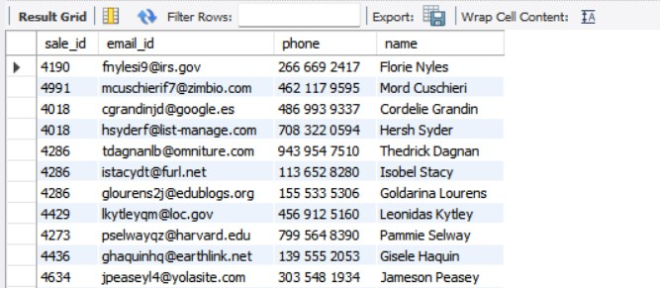

**4) title of the project and their nationality**

select title , nationality from art_work A join artsist_data D on A.artist_id = D.artist_id;

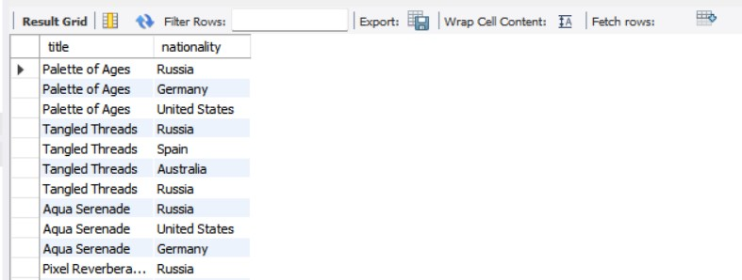**output:**

**5) find average price of the artwork in the medium category**

select avg(price) , nationality from art_work inner join artsist_data on art_work.artist_id = artsist_data.artist_id where nationality = "Russia";

**output:**

**6) right join use of the two table to show name with there medium and nationality**

select name , artwork_medium , nationality from art_work A right join artsist_data AD on A.artist_id = AD.artist_id;

**output:**

**7) joining 3 tables to extract name of the customer having spend more than 300000 on artwork**

SELECT c.name, c.email_id FROM customer c JOIN sell s ON c.customer_id = s.customer_id JOIN art_work a ON s.artwork_id = a.artwork_id

WHERE a.price > 300000;

**Output:**

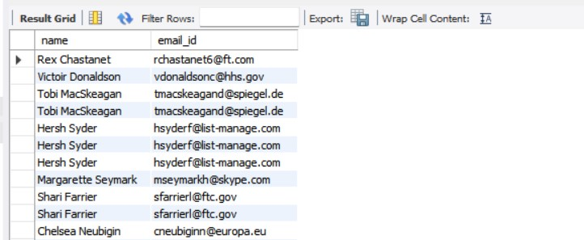

**SUBQUERIE QUERIES:**

**1) 2nd highest price of the art_work**

select max(price) from art_work;

select max(price) from art_work where price < (select max(price) from art_work);

**output:**

**2) Retrieve the names of customers who have purchased artworks worth more than $10,000**

select * from art_work where price > 10000;

select artwork_medium from art_work where price > any(select artist_id from art_work where price > 10000);

**output:**

**3) data of the artist whos salary is greater than the one who are from united states**

select nationality, price from artsist_data join art_work on artsist_data.artist_id = art_work.artist_id where nationality ="united states";

select * from art_work where price > (select max(price) from artsist_data join art_work on artsist_data.artist_id = art_work.artist_id where nationality ="united states");

**output:**

**4) show the data of the artwork who’s price the greater than average price**

select avg(price) from art_work;

select * from art_work where price > (select avg(price) from art_work);

**output:**

**5) having the name and email_id of the customer who spend more than 300000 on the art using joins and subqueries**

SELECT c.name, c.email_id FROM customer c

WHERE c.customer_id IN (SELECT s.customer_id

FROM sell s

JOIN art_work a ON s.artwork_id = a.artwork_id

WHERE a.price > 300000);

**Output:**

**BASIC QUESTIONS:**

**1) Find the average price of artworks in a specific size**

select avg(price) from art_work where size = "small";

**output:**

**2) Find the total value of artworks sold by the artist "Verena Cumbridge"**

select sum(price) from art_work inner join artsist_data on art_work.artist_id = artsist_data.artist_id where artsist_data.name = "Verena Cumbridge";

**output:**

**3) dropping the column from the table**

alter table exhibition_details drop column artist_id;

**output:**

**4) artwork having the top 5 price**

select * from art_work limit 5;

**output:**

**5) count of artist by sizes available**

select size, count(artist_id) from art_work group by size;

**output:**

**6) selecting particular value**

select * from sell where artwork_id = 2157;

select * from sell;

**output:**

**7) title of a project having size small**

select size, title from art_work where size = "small";

**output:**

**8) extract month name from the table**

select monthname(sale_date) from sell;

**output:**

**9) change mobile number of the customer**

update customer set phone = 7447547494 where customer_id = 3506;

select * from customer;

**output:**

**10) use of group by clause using joins getting sum of the price in the medium**

select artwork_medium ,sum(price), count(price) from art_work inner join sell on art_work.artwork_id = sell.artwork_id group by artwork_medium ;

**output:**

**11) use of logical operator AND**

select * from art_work where price > 100000 AND size = "large";

**output:**

**12) convert the email ID of the particular customer to the uper case**

select upper(name), customer_id from customer where customer_id = 3506;

select * from customer;

**output:**

**13) what is the day gap between start date and the date sold**

select datediff(submission_date,start_date ) from exhibition_details;

**output:**

**14) title of the art work having id 1,2,3,4,5**

select title, price from art_work where artist_id in (1,2,3,4,5);

**output:**

**15) change the column name and add the city is new york**

alter table sell add city varchar(30);

select * from sell;

update sell set city = "new york";

**output:**

**CONCLUSION:**

the Art Gallery Management Database project has successfully designed and implemented a comprehensive database system that effectively manages and stores information related to the art gallery's operations. The system has achieved its objectives by providing a user-friendly interface, improving data accuracy and accessibility, enhancing customer engagement, and supporting business growth through data-driven insights and reporting. With its robust and scalable design, the system is well-positioned to support the art gallery's future growth and expansion. The project demonstrates the importance of effective database management in the art industry, and its successful implementation will serve as a valuable resource for the gallery's continued success.